OPERATING SYSTEMS LAB EXPERIMENTS
1) STUDENT NAME: YADLAPALLI CHAITHANYA
2) REG.NO: 1925260210
3) SUBJECT NAME: OPERATING SYSTEMS
4) SUBJECT CODE: CSA0402 {SLOT:B}
5) SUBMITTED TO: PRISKILLA ANGEL RANI J

LAB EXPERIMENT 2
Identify the system calls to copy the content of one file to another and illustrate the same using a C program.
AIM: Identify the system calls to copy the content of one file to another and illustrate the same using a C program.
ALGORITHM:
- Include necessary headers: Include the header files <stdio.h>, <stdlib.h>, <fcntl.h> and <unistd.h> for working with file-related system calls.
- Declare variables: Declare variables to hold the file descriptors, the buffer and the file names.
- Open the source and destination files: Use the open() system call to open the source file in read-only mode and the destination file in write mode (creating it if it does not exist), obtaining a file descriptor for each.
- Read from the source file: Use the read() system call to read data from the source file into a buffer.
- Write to the destination file: Use the write() system call to write the data read from the source file into the destination file. Repeat until read() returns 0.
- Close the files: Use the close() system call to close the source and destination files.
PROGRAM:

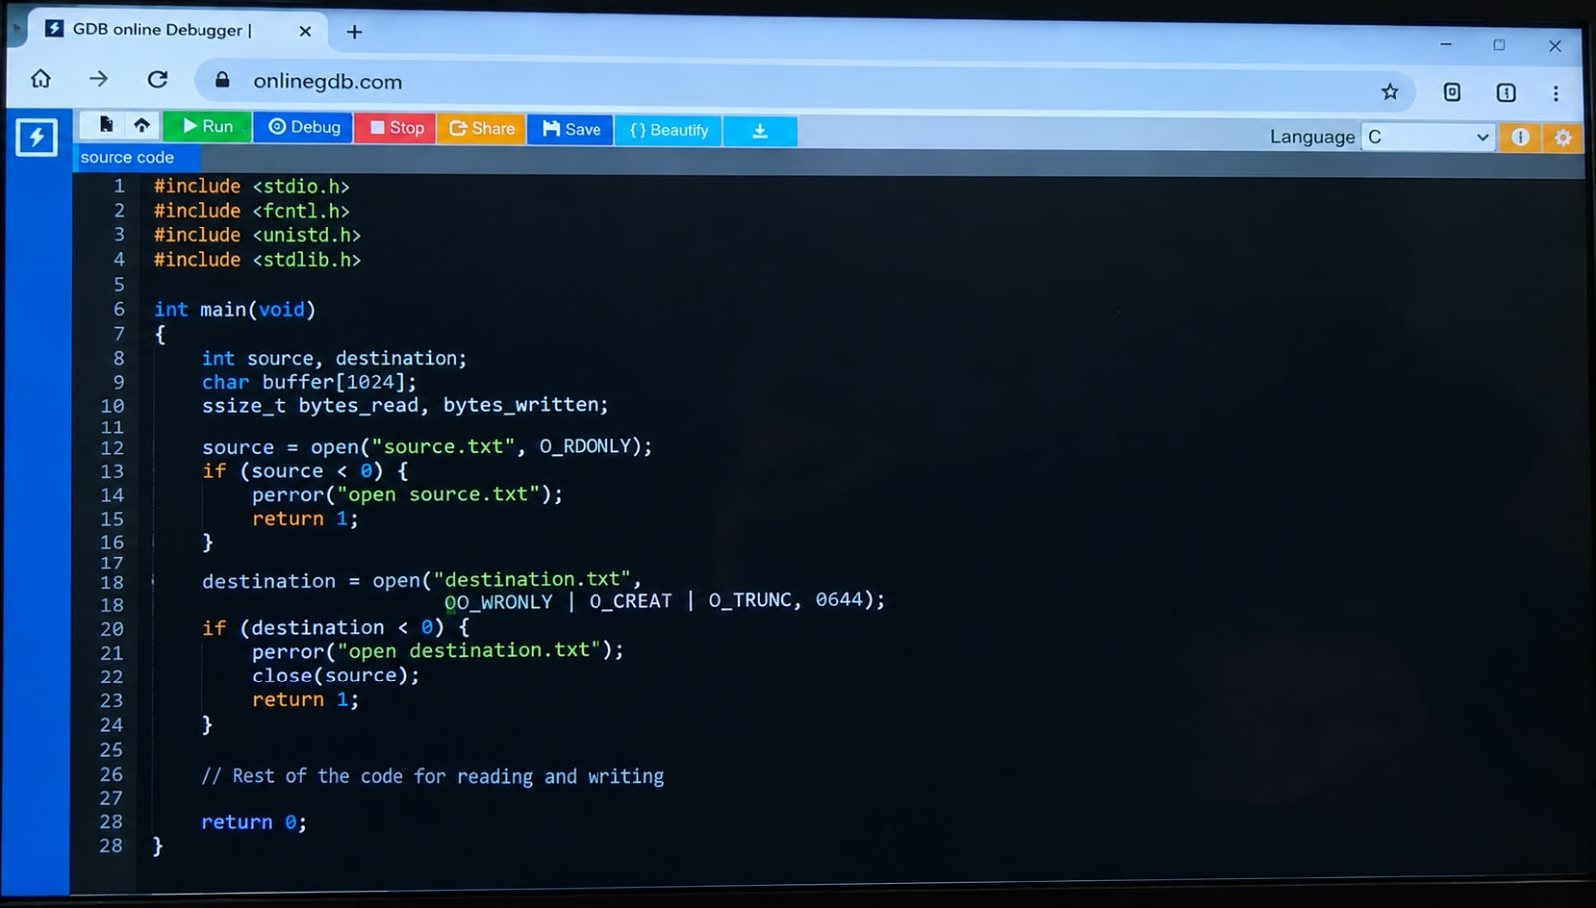

OUTPUT:
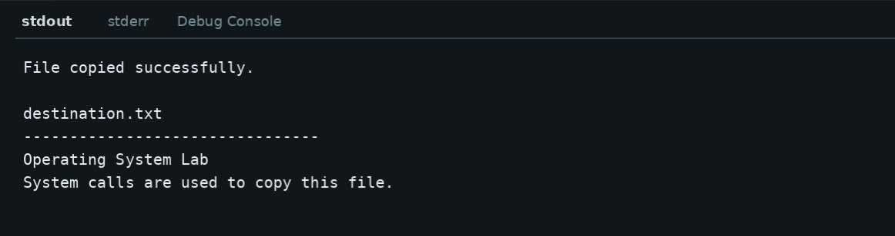

RESULT:
The contents of the source file were successfully copied to the destination file using the open(), read(), write() and close() system calls. The copied contents were successfully verified

